
PUCIT
Punjab University College of Information Technology

Final Documentation
Version 2.0

Online Restaurant Food Ordering Service In Train



Team ID- 00

Session: MCS Fall 2018

Project Advisor: Sir Asif Sohail

Submitted By

Name of Student | MCSF18M035
Name of Student | MCSF18M037
Name of Student | MCSF18M010
Name of Student | MCSF18M023
Name of Student | MCSF18M047

Punjab University College of Information Technology

University of the Punjab, Lahore.

STATEMENT OF SUBMISSION

This is to certify that Sidra Khan Roll No. MCSF18M035, Arooj Jamil Roll No. MCSF18M037, Ayesha Zafar Roll No. MCSF18M023, Amna Parvaiz Roll No. MCSF18M047 and Sibgha Mushtaq Roll No. MCSF18M010 have successfully completed the final project named as: Online Restaurant Food Ordering Service In Train, at the Punjab University College of Information Technology, University of The Punjab, Lahore, to fulfill the partial requirement of the degree of Masters in Computer Science.

_____________________
Project Office Supervisor
PUCIT, Lahore

___________________
Project Primary Advisor
Name: Sir Asif Sohail
Designation: Assistant Professor,
PUCIT, University of the Punjab,
Old Campus, Lahore.
PUCIT
_____________________
Project Examiner
Name: Write name of Project Examiner here
Designation: Write designation of Project Examiner here
PUCIT

Proofreading Certificate

It is to certify that I have read the document meticulously and circumspectly. I am convinced that the resultant project does not contain any spelling, punctuation or grammatical mistakes as such. All in all I find this document well organized and I am in no doubt that its objectives have been successfully met.

_____________________
Mr.
Business Communication and Technical Writing,
Lecturer, PUCIT

Acknowledgement

We truly acknowledge the cooperation and help make by Sir Asif Sohail, Assistant Professor of PUCIT. He has been a constant source of guidance throughout the course of this project. We would also like to thank Sir Asif Sohail , Assistant Professor at, PUCIT for his help and guidance throughout this project. We are also thankful to our friends and families whose silent support led us to complete our project.

Date:
June 26, 2020

Abstract

Due to ever increasing demand of transporting huge amount of information generated from various sources such as voice, data, video, etc., modern telecommunication networks have been transformed into all digital and broadband. Depending on the characteristics of information sources and the availability of facility, the mode of transportation can be either constant bit rate (CBR) using circuit switched networks or variable bit rate (VBR) using packet switched networks. For efficient utilization of the network, all kinds of information can be transported using BISDN (Broadband Integrated Services Digital Network) and ATM (Asynchronous Transfer Mode) technology. One important research area in Network Technology is the design of high-speed digital network with good performance. The issues need to be investigated include modeling of Variable Bit Rate video traffic, efficient assignment of different traffic classes with diverse quality of services, optimal bandwidth allocation, routing and call admission control etc. This project not only relates to study of Digital Subscriber Line, which is a Broadband technology to provide high-speed data, voice and video but also addresses the above-mentioned issues. What are the provisions made in DSL implement QoS quality of service.

Table of Contents

List Of Figures i
List of Tables ii
Table of Contents iii
1-Project Title 1
2-Project Overview Statement 2
3-High Level System Components 5
3.1 Component no.1 7
3.2 Component no.2 8
3.3 Component no.3 9
3.4 Component no.4 10

4-List of optional functional units 12
5-Application Architecture 13
6-Gantt chart 18

- Project Title
Online Restaurant Food Ordering Service In Train

- Project Overview Statement

User will install the application and register into it by providing some information. After registering into the application user has to enter from and to address. Then the list of restaurants according to location is displayed. Each restaurant displays the menu of a wide variety of food items. From that menu, the user can select the restaurant and food items and can order the food before reaching that particular station.
The order consists of a list of food items along with passenger details like PNR number, train number, compartment number, berth and seat number. When the food is delivered to him, he pays the bill.
On the other hand, the restaurant management receives the order and can see the order in the same app and sends a person to deliver the food to the passenger. As the train waits for sometime in the railway station and with the help of passenger’s details, the restaurant person can get on the train and deliver the food to passenger and collects the bill amount. The mode of payment is cash-on-delivery. Also, there is a facility of complaint box, where complaints about the quality of food can be given to restaurant management. So that the restaurant management can improve their quality of service. The restaurant management can see the list of orders date-wise.

Project Overview Statement Template
Project Title:
Online Restaurant Food Ordering Service in Train

Group Leader: Sidra Khan
Project Members:
Name | Registration # | Email Address | Signature
Arooj Jamil |  | Mcsf18m037@pucit.edu.pk
Ayesha Zafar |  | Mcsf18m023@pucit.edu.pk
Amina Pervaiz |  | Mcsf18m047@pucit.edu.pk
Sibgha Mushtaq |  | Mcsf18m010@pucit.edu.pk
Sidra Khan |  | Mcsf18m035@pucit.edu.pk

Project Goal:
To provide Restaurant food service to passengers while traveling by Train

Objectives:
Sr.#
1 | To manage details of Customers
2 | To manage details of Restaurants
3 | To manage orders and carts
4 | To manage payments efficiently

Project Success criteria:
Customers will successfully place orders and their orders will entertain on time.

Assumptions, Risks and Obstacles:
Assumptions:
- We assume that train will never be late in order to deliver order at time
- Application will work correctly
Risks:
- Database problem
- Tool expertise and skills
- Quality risk
- Requirement gathering
Obstacles:
- Unreliability in delivery & logistics staff.

Organization Address (if any): PUCIT, Lahore.

Type of project: Research Development
Target End users: Train Passengers, Restaurant

Development Technology: Object Oriented Structured
Platform: Web based Distributed
Desktop based Setup Configurations
Android Application________________
Suggested Project Supervisor:Sir Asif Sohail
Approved By:
Date:

- High Level System Components

Online restaurant food ordering information system:
- The component should have the whole database schema. Database contains all the information about customer, products and restaurants. The data can be added, updated and extracted by the database. It is managed on server side.
Customer interacting application:
- Through this component the customer interact with the system by login and perform the activities like placing order by providing required information.
Restaurants manager interacting application:
- By this component the manager interact with the customer, receive the order, manage the inventory and also receive the reviews of the customer about quality and services.

- List Of Optional Functional Units

- Web Based Application
- The Food Service Manager manages all the orders for restaurants.

- Application Architecture

Architecture of our application is three-tire architecture because it includes Communication between User and Restaurant via server and interenet.

- Gantt Chart

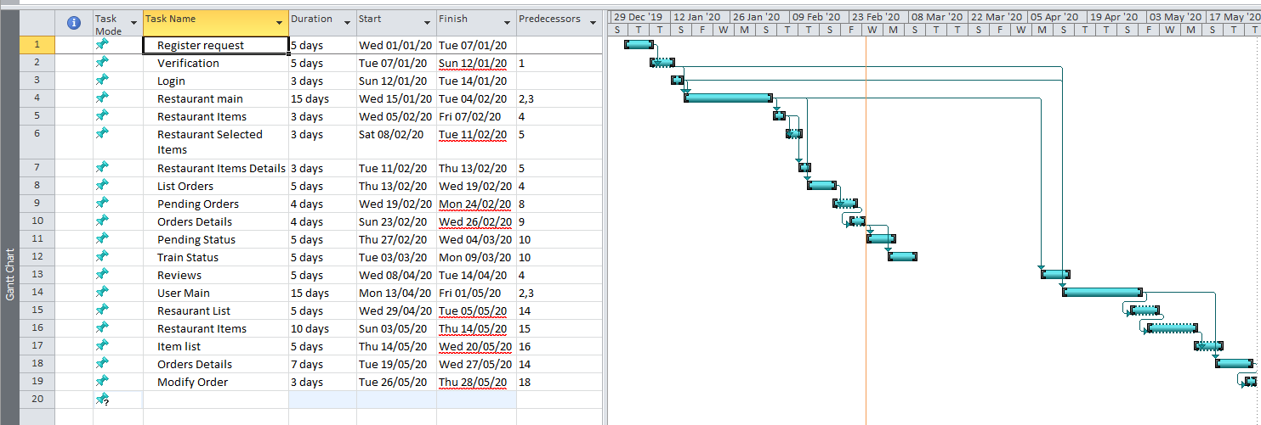

- References

Online Websites
- https://www.android.com/
- https://firebase.google.com/
- https://www.tutorialspoint.com/android/android_studio.htm
- https://developer.android.com/training/basics/firstapp

